Atividade número 2

Sistemas Embarcados e

IOT

Feito por Lorenzo Raveli, Samuel Kimura e Richard Murilo

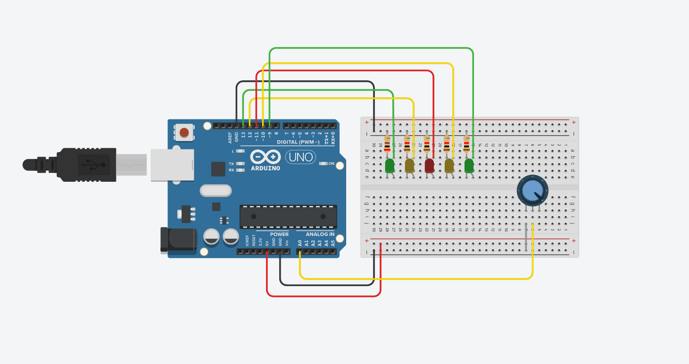

Código:

// C++ code
//
int valor = 0;
void setup()
{
pinMode(13, OUTPUT);
pinMode(12, OUTPUT);
pinMode(11, OUTPUT);
pinMode(10, OUTPUT);
pinMode(9, OUTPUT);
pinMode(A0, INPUT);
}
void loop()
{

valor = analogRead(A0);

if (valor < 180)
{
digitalWrite(13, LOW);
digitalWrite(12, LOW);
digitalWrite(11, LOW);
digitalWrite(10, LOW);
digitalWrite(9, LOW);
}
else if(valor < 360)
{
digitalWrite(13, HIGH);
digitalWrite(12, LOW);
digitalWrite(11, LOW);
digitalWrite(10, LOW);
digitalWrite(9, LOW);
}
else if(valor < 540)
{
digitalWrite(13, HIGH);
digitalWrite(12, LOW);
digitalWrite(11, LOW);
digitalWrite(10, LOW);
digitalWrite(9, HIGH);
}
else if(valor < 720) {
digitalWrite(13, HIGH);
digitalWrite(12, HIGH);
digitalWrite(11, LOW);
digitalWrite(10, LOW);
digitalWrite(9, HIGH);
}
else if(valor < 900) {
digitalWrite(13, HIGH);
digitalWrite(12, HIGH);
digitalWrite(11, LOW);
digitalWrite(10, HIGH);
digitalWrite(9, HIGH);
}
else
{
digitalWrite(13, LOW);
digitalWrite(12, LOW);
digitalWrite(11, LOW);
digitalWrite(10, LOW);
digitalWrite(9, LOW);
delay(250);
digitalWrite(13, HIGH);
delay(250);
digitalWrite(13, LOW);
digitalWrite(12, HIGH);
delay(250);
digitalWrite(12, LOW);
digitalWrite(11, HIGH);
delay(250);
digitalWrite(11, LOW);
digitalWrite(10, HIGH);
delay(250);
digitalWrite(10, HIGH);
digitalWrite (9, HIGH);
delay(250);
};
}

